Remembering Dirk Koning
by Tim Goodwin

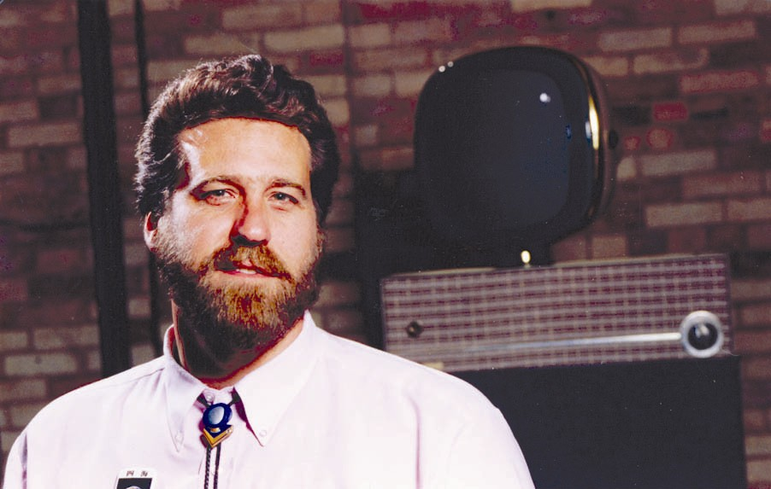
Dirk Koning, one of the great visionaries of community media and technology, passed away on February 10, 2005 at age 48 from complications during a routine heart procedure. Dirk was Executive Director of the Grand Rapids Community Media Center (GRCMC) since 1981, Chair of the Editorial Board of the Community Media Review, and President of the Washington D.C. based Alliance for Communications Democracy.
The ComTechReview asked Tim Goodwin, Managing Editor of the Community Media Review and close friend and colleague of Dirk Koning, to provide some appropriate eulogy and remembrance that we could share, along with links to numerous other testimonies that were being written. An extended version will appear in the next
CMR. ----the editors
“He stood six feet eight inches tall and he was dressed in a T-shirt with a slogan on it and his name was Dirk and he loomed over me to ask if I had a few minutes to talk about public access TV. Sure. Hell, yes. As soon as my pulse rate returned to normal. As soon as I could stop wondering whether I’d get to keep my credit cards. Actually, once I realized he did not intend to carve a zodiacal sign on my abdomen with the rusted edge of an Indiana license plate, I sort of welcomed his company.”
So went the opening lines from Pulitzer Prize-winning media critic Ron Powers in his July 1986 column in GQ magazine after the annual meeting of the National Cable Television Association.
Dirk Koning was a big guy! Five-foot-twenty he often would tell people who asked. It was his most obvious feature, and it served him and our mission well. Invariably, it found its way into scores of articles, even this one, and in many of the eulogies that followed his death February 10, 2005 from a routine heart procedure gone fatally wrong.
Big he was, but he was absolutely huge in our movement. He was, I would tell him, the best thing I ever did for community media, an honor I had as founding chair of the Grand Rapids Community Media Center when we hired him as executive director in 1981. But it was also one of the best things I ever did for myself. We became best of friends, soul mates, and fellow travelers in this cause of democratic communications.
Dirk came to define the very meaning of community media. The medium was never the message. It was never just television. Never just radio. Never just the internet. They were just tools to Dirk. He was, he said, a “community organizer, around the use of media to share information.”
Dirk understood early where it was heading. “It seemed to me such a natural evolution — convergence of all information into digital transmission,” he said, “Voice, video and data would not necessarily be independent worlds any longer, either in the media or the methods.” And then he set out to make it so at the Grand Rapids Community Media Center, which exemplified the community media center model with its public access television, FM radio station, nonprofit internet service provider, and media literacy institute.
But as big a man as Dirk was in this physical world and the community media movement, he was larger than life in the hearts and minds of those who knew him, and his death has left a bigger void in our souls than his physical presence ever did in our lives. To know Dirk was to be his friend, as I, and many of you in this movement, had the great joy to know.
It was no surprise that people came to his memorial services from three continents and from across the United States on Valentine’s Day 2005. You didn’t expect death from Dirk. He lived such a serendipitous life.
Dirk was a citizen of the world with a keen sense of justice. He carried this seed of liberty we call community media to far corners of the planet, from South Korea to South Africa to South America, Europe and hundred stops in between, maybe one of them in your own backyard. To Dirk, these were seeds of peace. To understand each other was the first step to respecting each other, a prelude to peace. He used the tools at his command and his own very unique presence.
We mourn our loss. As City of Grand Rapids Mayor George Heartwell said in his eulogy to Dirk, “Dirk, we are you, inheritors of what we mourn. You have, indeed, given us a rich inheritance. May God make us worthy to walk in your way, strong to stand against resistance, and unflinching in our commitment to justice.”

In our Summer, 2004 issue, the Com Tech Review offered Spotlight: Dirk Koning.

In our Summer-Fall, 1999 issue, Dirk wrote about The Grand Rapids, MI, Community Media Center 25 Year Plan.

The Grand Rapids Community Media Center Dirk Koning Tribute includes a bio of Dirk, links to other tributes and a eulogy, coverage of his passing, links to media that he participated in, and the opportunity to contribute to the $2 million GRCMC capital campaign to fulfill Dirk’s vision to acquire the Wealthy Theatre and provide computer and media access to residents of its neighborhood. You can also post your appreciations of Dirk here.

The Community Media Review Tribute includes remembrances from leaders in the community media and technology fields, and links to CMR articles written by Dirk.

Dirk Koning: A Life Beautifully Lived is a tribute blog posted the day of his passing.

Tim Goodwin is managing editor of CMR and founding chair of the Community Media Center in Grand Rapids, Michigan.

